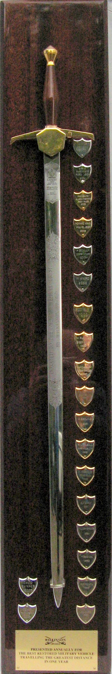
THE WILKINSON SWORD AWARD

WOULD YOU LIKE TO HOLD THIS PRESTIGIOUS TROPHY FOR A YEAR?

One of only six made by Wilkinsons for presentation to clubs of sporting or recreational interest, this magnificent sword was donated to the MVT in 1988. It is presented at the AGM to the owner/driver, who is a member of the MVT, of the best restored Second World War British, Canadian or American built military vehicle that has travelled the greatest distance under its own power to shows, rallies and other events in the UK.

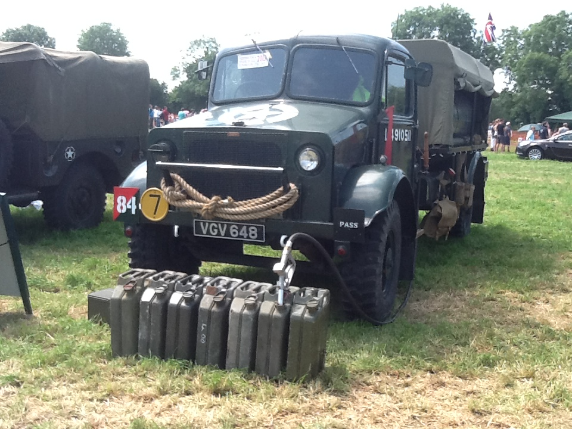
The 2015 Winner

It seems as though people think that a high mileage is needed to win the trophy. This is not the case. In the past distances of just over 1,000 miles have been sufficient. So, don’t hold back, have a go.

If you want to be considered for the award please complete the entry form to be found on the MVT web site and send it in by the date shown to:-

Michael Burne, Vice President, 61 New Road, Chilworth,
Guildford, Surrey GU4 8LP

